A-Start Algorithms

<https://www.codecademy.com/resources/docs/ai/search-algorithms/a-star-search>

**A* Search**

[BEAM Search](https://www.codecademy.com/resources/docs/ai/search-algorithms/beam-search)

[Best-First Search](https://www.codecademy.com/resources/docs/ai/search-algorithms/best-first-search)

[Breadth-First Search](https://www.codecademy.com/resources/docs/ai/search-algorithms/breadth-first-search)

[Depth-First Search](https://www.codecademy.com/resources/docs/ai/search-algorithms/depth-first-search)

[Gradient Descent](https://www.codecademy.com/resources/docs/ai/search-algorithms/gradient-descent)

[Greedy Best-First Search](https://www.codecademy.com/resources/docs/ai/search-algorithms/greedy-best-first-search)

[Hill Climbing](https://www.codecademy.com/resources/docs/ai/search-algorithms/hill-climbing)

[Simulated Annealing](https://www.codecademy.com/resources/docs/ai/search-algorithms/simulated-annealing)

[Stochastic Gradient Descent](https://www.codecademy.com/resources/docs/ai/search-algorithms/stochastic-gradient-descent)

[Back to AI](https://www.codecademy.com/resources/docs/ai)

1. [Docs](https://www.codecademy.com/resources/docs)/
2. [AI](https://www.codecademy.com/resources/docs/ai)/
3. [Search Algorithms](https://www.codecademy.com/resources/docs/ai/search-algorithms)/
4. **A* Search**

**A* Search**

Published Apr 12, 2023•**Updated May 31, 2024**

**[Contribute to Docs](https://www.codecademy.com/pages/contribute-docs)**

**A* Search** is an informed [best-first search algorithm](https://www.codecademy.com/resources/docs/ai/search-algorithms/best-first-search) that efficiently determines the lowest cost path between any two nodes in a directed weighted graph with non-negative edge weights. This algorithm is a variant of Dijkstra’s algorithm. A slight difference arises from the fact that an evaluation function is used to determine which node to explore next.

**Evaluation Function**

The evaluation function, **f(x)**, for the A* search algorithm is the following:

f(x) = g(x) + h(x)

Where **g(x)** represents the cost to get to node **x** and **h(x)** represents the estimated cost to arrive at the goal node from node **x**.

For the algorithm to generate the correct result, the evaluation function must be **admissible**, meaning that it never overestimates the cost to arrive at the goal node.

**The Algorithm**

The A* algorithm is implemented in a similar way to Dijkstra’s algorithm. Given a weighted graph with non-negative edge weights, to find the lowest-cost path from a start node **S** to a goal node **G**, two lists are used:

* An **open list**, implemented as a priority queue, which stores the next nodes to be explored. Because this is a priority queue, the most promising candidate node (the one with the lowest value from the evaluation function) is always at the top. Initially, the only node in this list is the start node **S**.
* A **closed list** which stores the nodes that have already been evaluated. When a node is in the closed list, it means that the lowest-cost path to that node has been found.

To find the lowest cost path, a search tree is constructed in the following way:

1. Initialize a tree with the root node being the start node **S**.
2. Remove the top node from the open list for exploration.
3. Add the current node to the closed list.
4. Add all nodes that have an incoming edge from the current node as child nodes in the tree.
5. Update the lowest cost to reach the child node.
6. Compute the evaluation function for every child node and add them to the open list.

Just like in Dijkstra’s algorithm, the lowest cost is updated as the algorithm progresses in the following way:

current_lowest_cost = min(current_lowest_cost, parent_node_cost + edge_weight)

All nodes except for the start node start with a lowest cost of infinity. The start node has an initial lowest cost of 0.

The algorithm concludes when the goal node **G** is removed from the open list and explored, indicating that a shortest path has been found. The shortest path is the path from the start node **S** to the goal node **G** in the tree.

Note: The algorithm ends when the goal node **G** has been explored, NOT when it is added to the open list.

**Example**

Consider the following example of trying to find the shortest path from **S** to **G** in the following graph:

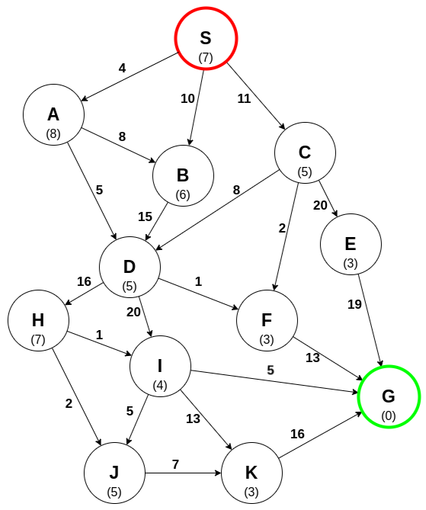

Each edge has an associated weight, and each node has a heuristic cost (in parentheses).

An open list is maintained in which the node **S** is the only node in the list. The search tree can now be constructed.

Exploring **S**:

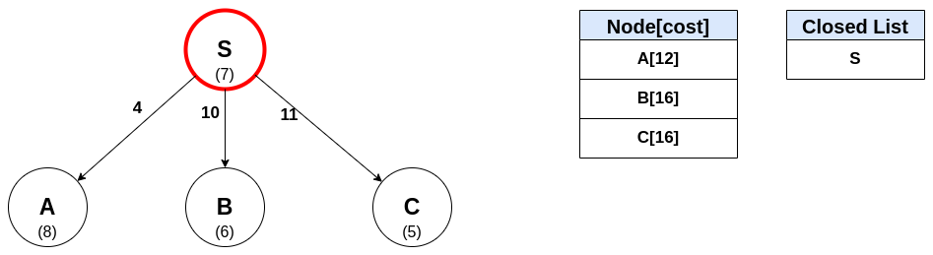

**A** is the current most promising path, so it is explored next:

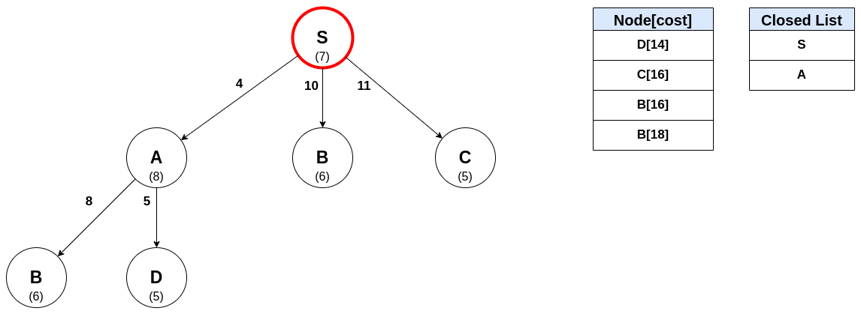

Exploring **D**:

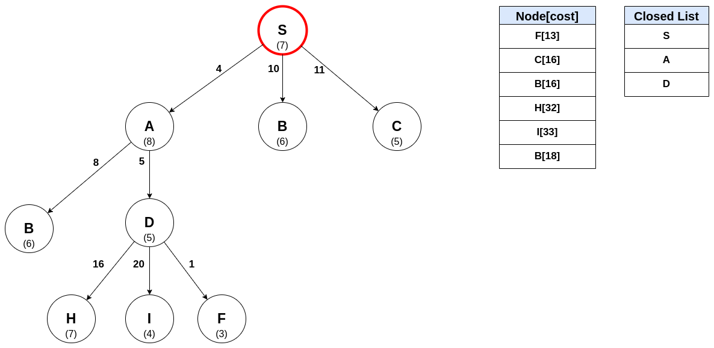

Exploring **F**:

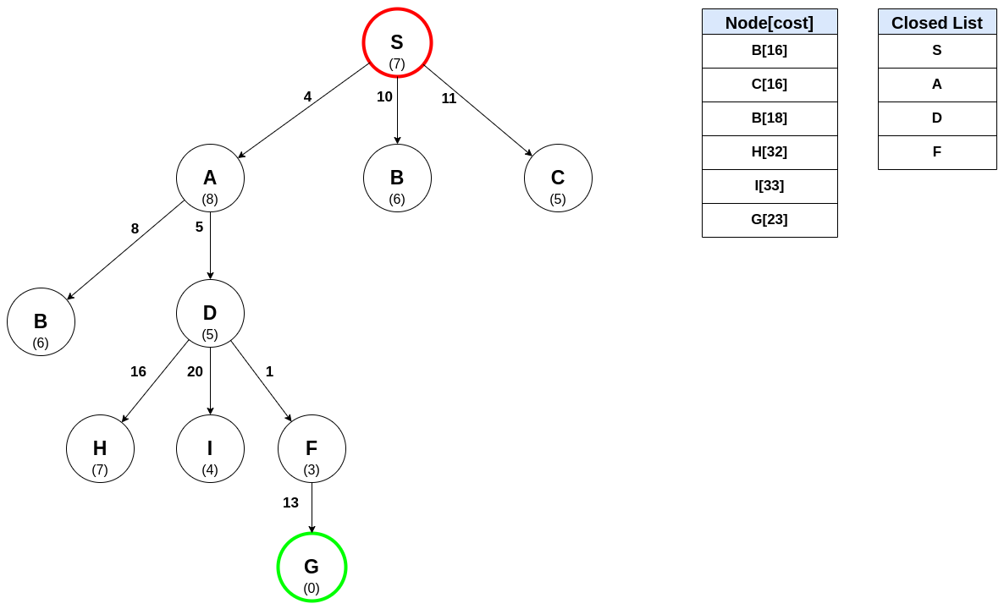

Notice that the goal node **G** has been found. However, it hasn’t been explored, so the algorithm continues because there may be a shorter path to G. The node **B** has two entries in the open list: one at a cost of 16 (child of **S**) and one at a cost of 18 (child of **A**). The one with the lowest cost is explored next:

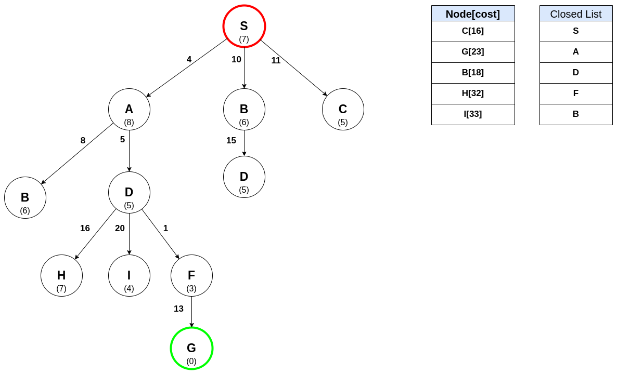

Exploring **C**:

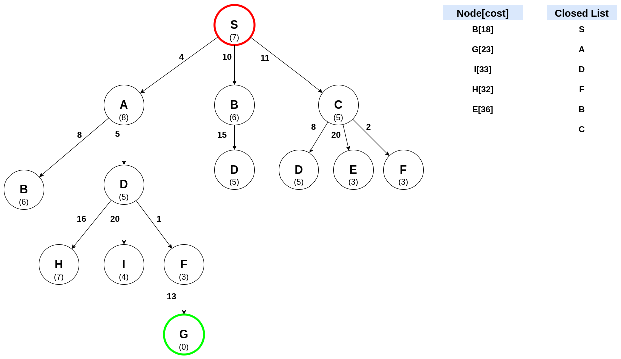

The next node in the open list is again **B**. However, because **B** has already been explored, meaning a shortest path to **B** has been found, it is not explored again and the algorithm continues to the next candidate.

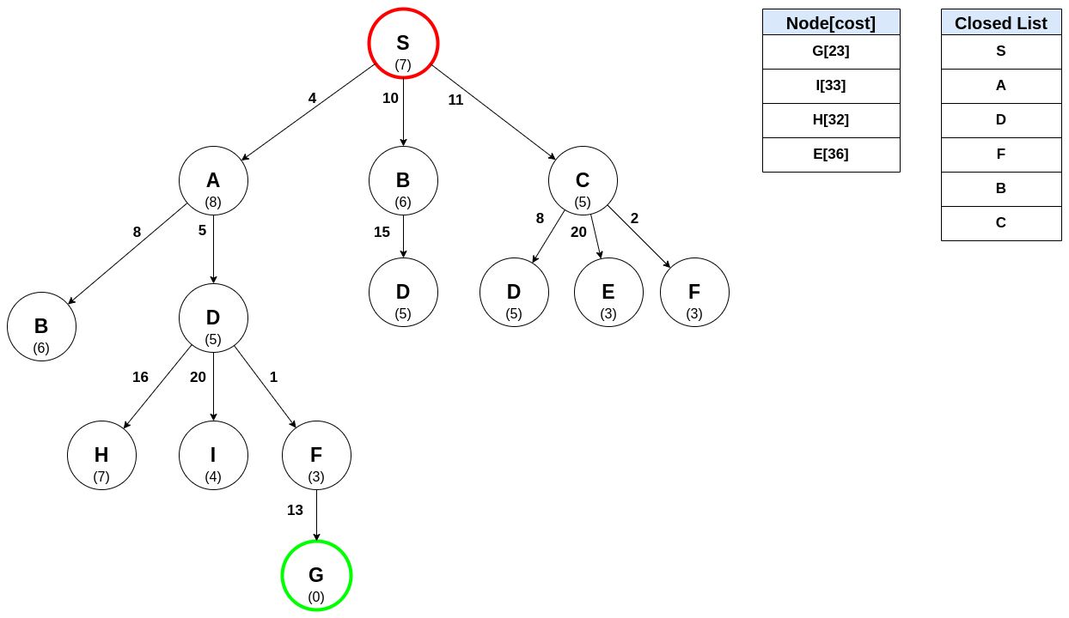

The next node to be explored is the goal node **G**, meaning the shortest path to **G** has been found! The path is constructed by tracing the graph backward from **G** to **S**:

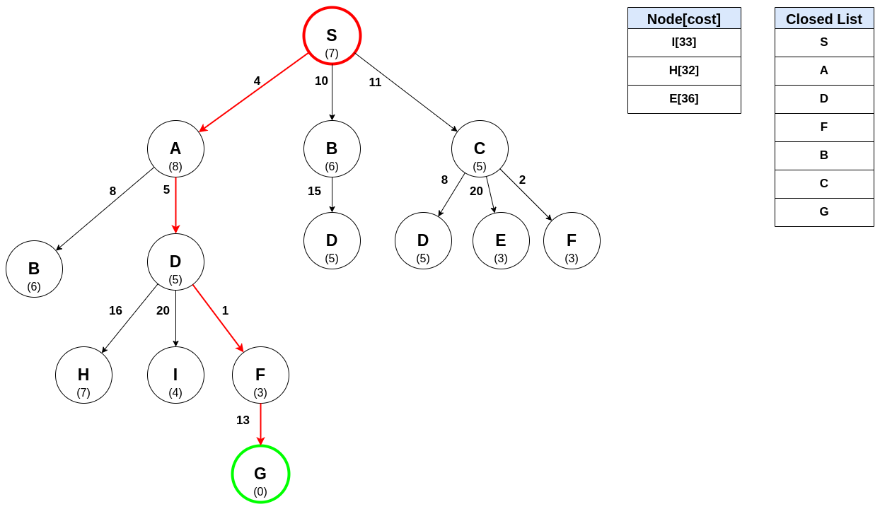

**AI Search Algorithms With Examples**

The Application of AI Search Algorithms To Solve Real-World Problems

[Nerd For Tech](https://medium.com/nerd-for-tech?source=post_page-----54772c6d973a--------------------------------)

Finding for something known is called ‘Search’ in contrast to what we call ‘Research’ which is looking for something unknown. As the name suggests the duty of AI Search algorithms is also, searching. Problem-solving is one direct application of search. Effective and efficient solutions can be formulated for real-world problems with the help of AI search algorithms.

Before diving deep into algorithms, first, we should understand the nature of a problem and some related terminology. Generally, a problem consists of 04 major components as States, Actions/Operations, Goals, Path. Simply, problem-solving can be identified as a process involving transforming a set of states through actions or operations to a goal along a path/paths.

**State-Space**

State-space consists of all the possible states together with actions to solve a specific problem. In the graphical representation of state space (such as trees), the states are represented by nodes while the actions are represented by arcs. Any state space has an initial ‘Start’ node and an ending ‘Goal’ node or multiple Goal States. The path from the initial start node to the final goal node is known as the ‘Solution’ for the particular problem.

***Note:****A problem may have multiple goals as well as paths.*

***Problem 01:***

For a clear understanding of state space, consider the following problem [Figure 2].

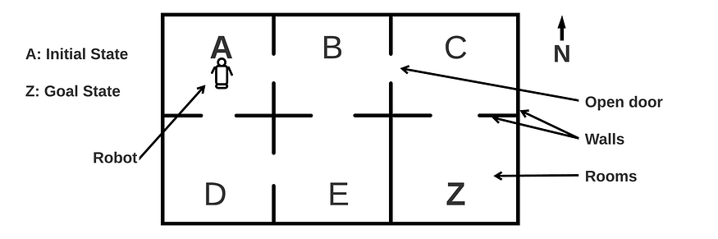

Figure 2: Example Problem (Image designed by [Author](https://medium.com/@pawara73))

Imagine there is a robot in room ‘A’ (initial state), and it needs to go to room ‘Z’ (goal state). We can draw a state space in terms of a tree if we consider all the possible movements of the robot in each room (node). For example, when the robot is at initial state A, he can either go to B or D. When the robot moved to the next state B, he can move to C, E, or back to A [Figure 3].

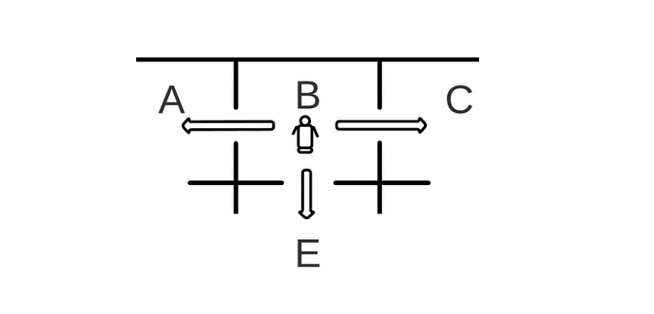

Figure 3: Possible paths for robot at state B (Image designed by [Author](https://medium.com/@pawara73))

Based on all the possible movements of the robot at each state we can draw the state space for the above scenario as follows:

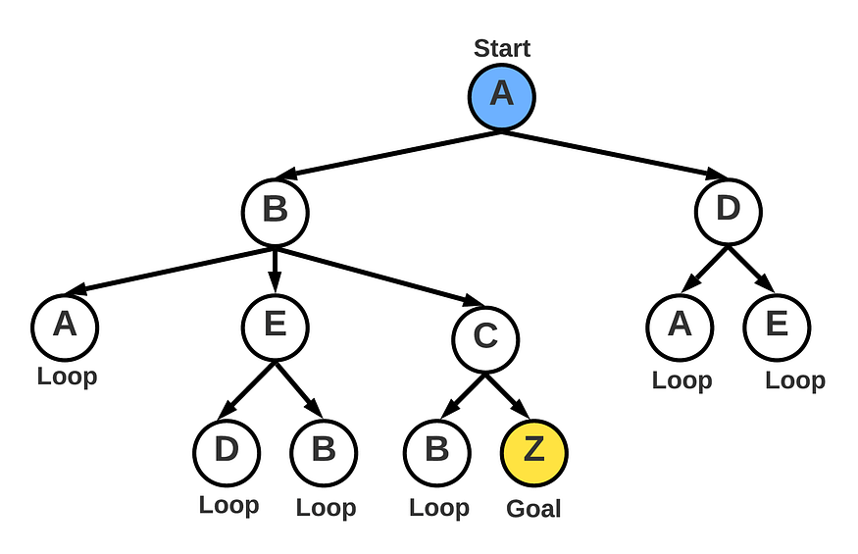

Figure 4: State-space diagram (Image designed by [Author](https://medium.com/@pawara73))

We can identify many paths beside the direct path A, B, C, Z.

Ex: A B C Z  
 A B A B C Z  
 A D E B C Z  
 A D E B A B C Z  
 ....

It can be observed that some paths are shorter while others are longer. The real problem arises here. We can figure out the best/shortest path in cases like the above example where the state space is small. But imagine a state-space with hundreds of thousands of nodes. How can we explore such a state-space?

The solution is nothing but search algorithms. In the next chapter, we will discuss the 08 major search algorithms in Artificial Intelligence.

**Search algorithms**

Since the state spaces are very large in general, we employ search algorithms to navigate through the state-space effectively and efficiently. A search algorithm defines how to find the path (solution) from the initial state to the goal state. Different algorithms define different methods to move from the current state (node) to the next state (node). Some algorithms provide just the systematic ways to explore the state space while others tell how to explore effectively and efficiently.

The search algorithms are of two types as uninformed and informed search algorithms [Figure 5]. Informed search algorithms provide just a systematic way to explore the state space and no additional information are provided to support the search process. Breadth-first search, Uniform search, Depth-first search, Depth limited search, Iterative deepening search, and Bi-direction search are the 06 main uninformed search algorithms.

On the other hand, informed search algorithms such as Greedy search and A* search algorithms are based on additional information which makes the searching procedure both systematic and effective.

***Note:****There are some AI search algorithms that do not fall under any of the above major categories. Because, there are problems that do not need a specific path to solve but concern on whether the searching process can come to a goal state. When applying search for such problems, we just find the best available node in the vicinity (local search), or searching in competitive environment (adversarial search).*

*Ex:- Some games like chess, hill climbing, certain design and scheduling problems.*

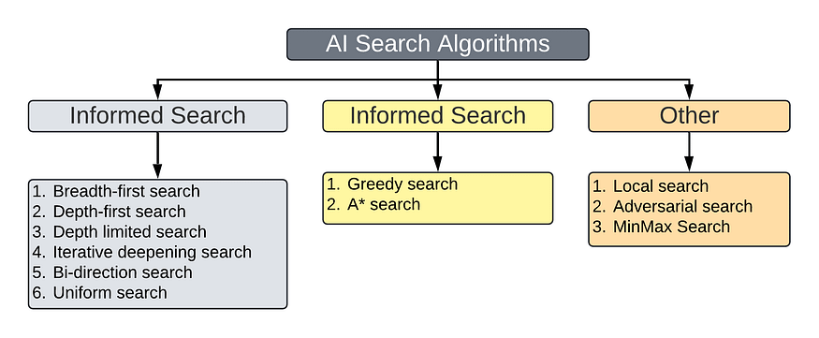

Figure 5: AI Search Algorithms Classification (Image designed by [Author](https://medium.com/@pawara73))

**Search algorithm evaluating criteria:**

There are 04 criteria we employ to evaluate the performance of each of those search algorithms we mentioned above. They are:

1. **Completeness:** Ability to find a solution when there is a solution (The algorithm should not miss any node before reaching any goal node/end of the state space).
2. **Optimality:** Ability to find the highest quality solution (The algorithm should find the goal nodes in shallower level first).
3. **Time complexity:** How long the algorithm takes to process the nodes. (The execution time of the algorithm/ CPU time)
4. **Space complexity:** How much memory is used by the algorithm to store nodes.

In order to understand the application above algorithm first consider the following scenario. Next, we will apply each search algorithm to find the solution and compare the performance according to the evaluating criteria mentioned.

**Problem 02:**

How to choose the right set of exercise equipment at the gym to save time and burn maximum calories.

“Gymnasiums are full of different exercise equipment with different calorie burn rates. When doing exercise, it is important to cover the full-body, rather than a part of the body. Selecting exercise techniques with the least recovery time can reduce the overall time taken to do the exercise as well as any damages to the body. Therefore selecting the right exercise machine to burn the target calorie, and involving the whole body in to exercise process and with least prone to cause injuries is important. The scenario is based on the information given in table 1 and state-space [Figure 6].”

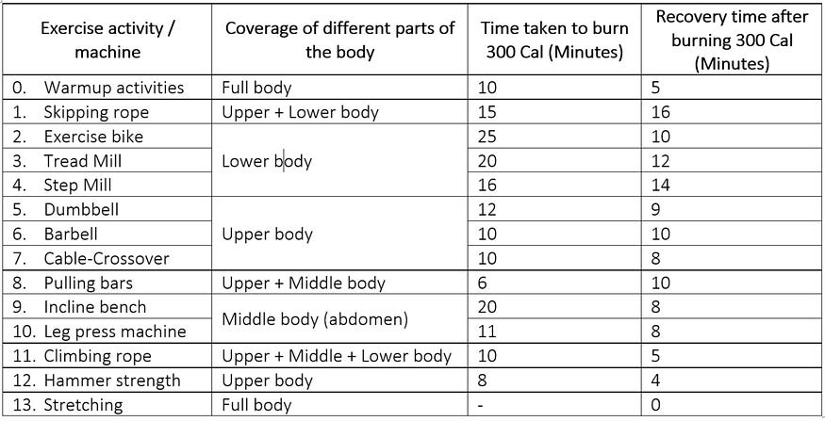

Table 1: Different exercise equipment vs calorie burn (Designed by [Author](https://medium.com/@pawara73))

**Path Cost:** Time taken to burn 300 Cal (minutes)  
**Heuristic Value:** Recovery time required after burning 300 Cal (minutes)

***Note:****the units of both path costs and heuristic values are the same.*

Based on the above information the following state-space diagram is drawn [Figure 6]. This is a problem with multiple paths but a single goal node. The following diagram is drawn including path costs and heuristic values also. But note, that additional information is required for certain algorithms only. Down each path, whole-body sections (upper body, middle body and lower body) is covered.

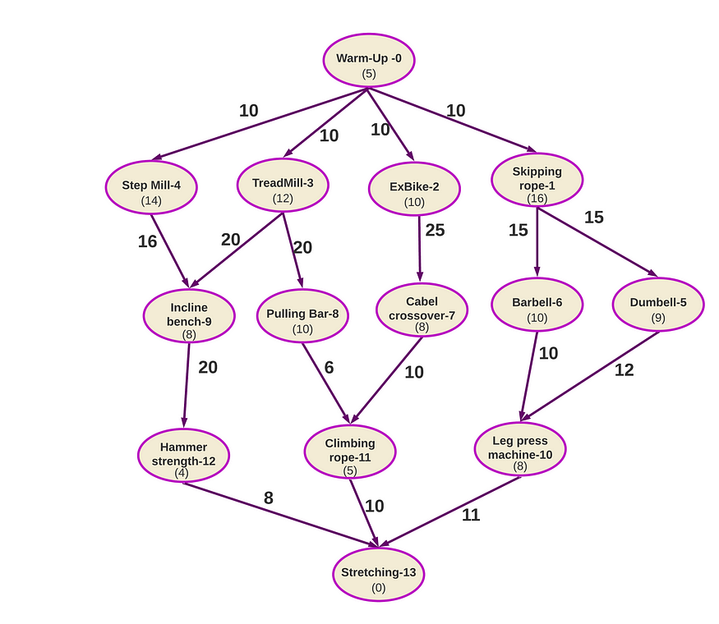

Figure 6: State-space for the problem 02 (Image designed by [Author](https://medium.com/@pawara73))

Now we will discuss the features of uninformed and informed search algorithms while applying them to the above state-space.

***Note:****To implement the search, usually we use two lists to store the nodes as OPEN (nodes to be visited/fringe) and CLOSED (nodes already visited).*

For the demonstration of each algorithm, I have employed an online simulation tool: [AI Search (ali-elganzory.github.io)](https://ali-elganzory.github.io/AI-Search/)

**1. Uninformed Search Algorithms**

Uninformed search algorithms follow a systematic way of exploring across the state space and do not employ additional information (Heuristics)

**1.1 Breadth-first Search (BFS)**

As the name implies, the BFS algorithm explores the state space layer-by-layer [Figure 7]. When we explore a node, children are always added to the end of the OPEN list. When removing nodes from OPEN to be added to the CLOSED, check whether it is the goal node, if it is, then stops.



Figure 7: State-Space (left) and state-space traversal (right) in breadth-first search (Image designed by [Author](https://medium.com/@pawara73))

**Path:** 0, 1, 5, 10, 13

The traversal is in the CLOSED list. But the OPEN list and CLOSED list altogether contribute to the space complexity since the total number of nodes stored in the memory is the summation of OPEN and CLOSED lists.

Since the nodes beyond the goal node in the OPEN list are not processed the time complexity of BFS is associated with the number of nodes in the CLOSE list only. Since the state-space is explored layer-by-layer, if there is a solution, it is **definitely** found. Hence BFS is complete. BFS is optimal because the goal nodes in the shallower level are found first.

In BFS, the space complexity for state-space with a branching factor ‘b’ and the level in which the goal node found is ‘d’, is **O(*bᵈ⁺¹*)**. The time complexity is**O(*bᵈ*)** because although memory contains nods from ‘d+1’, nodes beyond ‘d’ are not processed in BFS.

**1.2 Depth-First Search (DFS)**

In DFS, the state space is explored along branches depthwise. It checks for the goal node along each branch.



Figure 8: State-Space (left) and state-space traversal (right) in depth-first search (Image designed by [Author](https://medium.com/@pawara73))

**Path:** 0, 4, 9, 12, 13

Since DFS identifies the deeper level goals before the shallower level ones, it is not optimal. DFS is not complete also. Because, if there is a loop in the one branch in the state space, even though we can find the goal node along another branch, still we can not go to that branch due to the loop.

Amazingly, the DFS has very low memory usage. It only stores the nodes along the branch, thus in each level minimum number of nodes are stored unlike in BFS where all the nodes get stored in each level. In the worst-case scenario, if the maximum depth of the search tree with branching factor ‘b’, is ‘m’ then the space and time complexities of DFS are **O(*bm*)** and **O(*bᵐ*)** respectively.

**1.3 Depth-Limited Search (DLS)**

In DFS you noticed that it is not optimal i.e.: if the goal is present at the shallower level are not found first. What if we set a limit to the depth being searched? It is DFS, where we can set a depth limit so that beyond that tree is not searched. So, if the goal is at a shallower level, then it is found quickly. But what if the goal is beyond the level we set? That’s what happened in our example scenario also [Figure 9]. Here, the depth is set to level 3, but the goal node is at level 4, so the search will never be able to find the goal node.



Figure 9: State-space traversal depth-limited search (Image designed by [Author](https://medium.com/@pawara73))

**Path:** Not found

In DLS, it is neither complete nor optimal because not all the nodes in the graph are checked and goal nodes cannot be found effectively. If we set a depth limit of ‘l’ for state-space with branching factor ‘b’ then the space and time complexities of DLS will be **O(*bl*)** and**O(*bˡ*)**, respectively.

**1.4 Iterative Deepening Search (IDS)**

In IDS, we increase the depth limit iteratively and execute the DFS until the goal node is found. The use of DFS helps in the lesser usage of memory to store nodes. And since the state-space is explored iteratively (layer-by-layer) if the goal node is in a shallower level (optimal), it is found first before going deeper, and all the nodes in a layer are checked completely (completeness).

Therefore IDS possesses the advantage of both DFS (by consuming less memory space) and BFS (complete and optimal) and it has eliminated the problems faced by DLS. The animation below shows the traversal through state space under IDS [Figure 10].



Figure 10: State-Space (left) and state-space traversal (right) in iterative-deepening search (Image designed by [Author](https://medium.com/@pawara73))

**Path:** 0, 4, 9, 12, 13

**1.5 Bi-directional Search (BDS)**

BDS is applied if we run two simultaneous BFS search algorithms: one from ‘start node’ to ‘goal node’ forward, and the other is from ‘goal’ to ‘start’ backwards, waiting for two searches to meet each other at the middle. because of this, both the time and space complexities become two times the half of that BFS (which is extremely smaller than O(*bᵈ*) of BFS). For a graph with branching factor ‘b’ and depth ‘d’, space and time complexities of BDS are denoted by **O(*bᵈ/²*)**.

***Note:****Since, 2×O(*bᵈ/²*) ≈ O(*bᵈ/²*), we use O(*bᵈ/²*) instead of 2O(*bᵈ/²*)*

But BDS is not applicable for situations like our example, where some children nodes have multiple parents (Ex: node-9 has node-3 and node-4 as parent nodes). Because the backward search algorithm cannot determine which node to follow from the multiple parent nodes.

**1.6 Uniform Cost Search (UCS)**

In UCS, each action (edge) from one node to another node is given a value. And each node is associated with a **total path cost** which is calculated from the ‘start node’ to the particular node. In UCS, this total path cost is considered instead of depth.

Similar to BFS, we expand the lowest cost node rather than the shallowest node in the OPEN list. Although in BFS, the cross-connections in the graph are neglected, here they are considered since each path is associated with a value.



Figure 11: State-Space (left) and state-space traversal (right) in uniform cost search (Image designed by [Author](https://medium.com/@pawara73))

**f(n) = g(n)**  = Summation(total path cost to each node from start node)  
 = (Node0-Node1)+(Node1-Node6)+(Node6-Node10)+(Node10-Node13)  
 = 10 + 15 + 10 + 11  
 = 46 (path cost)  
**Path:** 0, 1, 6, 10, 13 (Path with the least path cost)

According to our scenario, only the lowest costs path is calculated above. In the animation [Figure 11] you can observe the traversal is quite similar to BFS but considering the cost. Therefore UCS is complete and optimal and the time and space complexities are similar to that of BFS’s which are **O(*bᵈ*)**, and**O(*bᵈ⁺¹*)**, respectively.

**2. Informed Search Algorithms**

In informed search algorithms additional information is used to make the search more efficient and effective. That additional information is called **heuristics**. Heuristics are not theories but some common sense experience like information.

**Ex:***If you travel between two cities by car, the heuristic will be the traffic level. (Directly the path cost will be the distance between two cities. Additional information such as displacement and traffic between the cities are considered as the heuristics)*

In informed search algorithms, to find the best node to be visited next, we use an *evaluation function* **f(n)**which assists the child node to decide on which node to be visited next. Then we traverse to the next node with the **least f(n)** value. Depending on the f(n), we have two informed search algorithms as greedy search and A* search algorithms.

**2.1 Greedy Search Algorithms**

In greedy search, the heuristic values of child nodes are considered. The path is determined by calculating the path with the nodes with the lowest heuristic values. Another fact to be noticed is that usually the initial node has the highest heuristic value and the goal node has the lowest. But there can be exceptions like getting a mid-range value for the initial node also.



Figure 12: State-Space (left) and state-space traversal (right) in greedy search (Image designed by [Author](https://medium.com/@pawara73))

**f(n) = h(n)** = Summation(Heuristic values of nodes)= Node0 + Node2 + Node7 + Node11 + Node13  
 = 5 + 10 + 8 + 5 + 0  
 = 28  
**Path:** 0, 2, 7, 11, 13

In greedy search, you can see we do not visit all the child nodes of a particular node. We find heuristics of each child node only the one with the lowest value is inserted to the OPEN list to be processed. Therefore greedy search is not complete. As well as this is not the best path (not the shortest path - we found this path in uniform cost search). Therefore greedy search is not optimal, also. As a solution, we should consider not only the heuristic value but also the path cost. Here, comes the A* algorithm.

**2.2 A* Search Algorithms**

In the A* algorithm, we consider both path cost and heuristics. In A* the f(n) function comprises two components: path cost [g(n)] and heuristic value ([h(n)]. The f(n) value for node ‘a’ can be calculated as follows:

f(n)ₐ = g(n)ₐ + h(n)ₐf(n)ₐ = Evaluation value at the particular node (node 'a')  
g(n)ₐ = Total path cost from start node to particular node(node 'a')  
h(n)ₐ = The heuristic value of the particular node(node 'a')

Now, we will find the best path according to the A* search algorithm for our previous problem. We have to find the f(n) value for each node and select the child node with the least f(n) value and traverse until meeting the goal node. In the example, only the f(n) values of goals in the path are mentioned.



Figure 13: State-Space (left) and state-space traversal (right) in A* search (Image designed by [Author](https://medium.com/@pawara73))

At Node-0 :  
 f(n)₀ = 0 + 5 = 5  
At Node-3:  
 f(n)₃ = 10 + 12 = 22  
At Node-8:  
 f(n)₈ = 30 + 10 = 40  
At Node-11:  
 f(n)₁₁ = 36 + 5 = 41  
At Node-13:  
 f(n)₁₃ = 46 + 0 = 46  
  
f(n)ₜₒₜₐₗ = f(n)₀ + f(n)₃ + f(n)₈ + f(n)₁₁ + f(n)₁₃ = 154**Path:** 0, 3, 8, 11, 13

A* algorithm is complete since it checks all the nodes before reaching to goal node/end of the state space. It is optimal as well because considering both path cost and heuristic values, therefore the lowest path with the lowest heuristics can be found with A*. One drawback of A* is it stores all the nodes it processes in the memory. Therefore, for a state space of branching factor ‘b’, and the depth ‘d’ the space and time complexities of A* are denoted by **O(*bᵈ*)**. The time complexity of A* depends on the heuristic values.

**Summary of The Comparison of Search Algorithms**

The summary of each informed search algorithm can be summarized as follows.

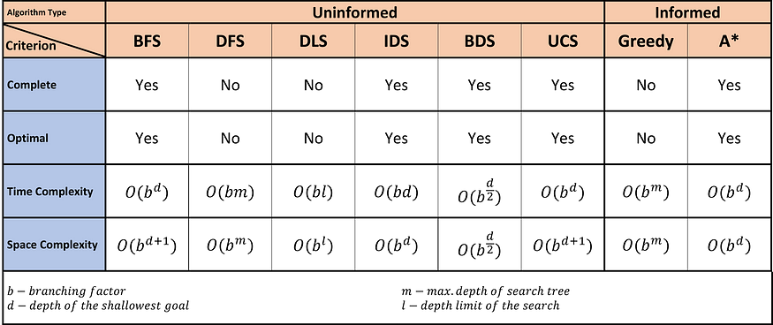

Table 2: The comparison of search algorithms under 04 major evaluation criteria (Designed by [Author](https://pawara73.medium.com/))

***Note:****All BFS, IDS, BDS (if the algorithm can be applied in both directions), and UCS are complete if the branching factor of the state space graph is finite. If the algorithm can be applied in both direction and the step costs are the same, then BDS is complete.*

**Conclusion**

In informed search algorithms the exploration across the state space is performed based on the heuristic values but in informed search, it is carried out particularly in a systematic way specific to the algorithm.

When considering uninformed search algorithms, the best search algorithm in terms of completeness, optimality, time complexity and space complexity is the Bi-directional Search algorithm if each child node in the state space has only one parent node. But if the child nodes have more than parent nodes in the state-space Bi-directional search is not applicable and it is the IDS Algorithm because it is optimal, complete, space complexity is in the order of (bm) and time complexity is the order of (bᵈ) which is similar to others.

The best search algorithm is A* because it is optimal, complete and employ additional information (heuristics), so the solution is better than that of other algorithms.

**References:**

<https://www.cin.ufpe.br/~tfl2/artificial-intelligence-modern-approach.9780131038059.25368.pdf>

<http://www.ccpo.odu.edu/~klinck/Reprints/PDF/wikipediaNav2018.pdf>

[AI](https://medium.com/tag/ai?source=post_page-----54772c6d973a---------------ai-----------------)

[Artificial Intelligence](https://medium.com/tag/artificial-intelligence?source=post_page-----54772c6d973a---------------artificial_intelligence-----------------)

[Search Algorithm](https://medium.com/tag/search-algorithm?source=post_page-----54772c6d973a---------------search_algorithm-----------------)

[Algorithms](https://medium.com/tag/algorithms?source=post_page-----54772c6d973a---------------algorithms-----------------)

[Nerd For Tech](https://medium.com/nerd-for-tech?source=post_page-----54772c6d973a--------------------------------)

[73pawara@gmail.com](mailto:73pawara@gmail.com), (+94) 71 869 7440👨🏻‍🎓 An enthusiastic IT undergraduate, with the sole goal of sharing information related to the IT industry 👨‍💻

Follow

More from Pawara Siriwardhane, UG and Nerd For Tech

**[How to upload large files to GitHub repository](https://medium.com/linkit-intecs/how-to-upload-large-files-to-github-repository-2b1e03723d2?source=author_recirc-----54772c6d973a----0---------------------892d4046_b05b_417a_b02a_722aa8bac154-------)**

[This article is solely for newbies in Github regarding how to push large files to your Github repository.](https://medium.com/linkit-intecs/how-to-upload-large-files-to-github-repository-2b1e03723d2?source=author_recirc-----54772c6d973a----0---------------------892d4046_b05b_417a_b02a_722aa8bac154-------)

[Nerd For Tech](https://medium.com/nerd-for-tech?source=author_recirc-----54772c6d973a----1---------------------892d4046_b05b_417a_b02a_722aa8bac154-------)

**[Why Zig programmers are making so much money](https://medium.com/nerd-for-tech/why-zig-programmers-are-making-so-much-money-5f03a0838cf6?source=author_recirc-----54772c6d973a----1---------------------892d4046_b05b_417a_b02a_722aa8bac154-------)**

[Are you wondering why Zig programmers make so much money? Guess what? It is not what you are thinking.](https://medium.com/nerd-for-tech/why-zig-programmers-are-making-so-much-money-5f03a0838cf6?source=author_recirc-----54772c6d973a----1---------------------892d4046_b05b_417a_b02a_722aa8bac154-------)

**[I discovered this amazing IntelliJ feature after 6 years.](https://medium.com/nerd-for-tech/i-discovered-this-amazing-intellij-feature-after-6-years-72eeb58f1349?source=author_recirc-----54772c6d973a----2---------------------892d4046_b05b_417a_b02a_722aa8bac154-------)**

[How a random debugging session helped me discover this amazing feature.](https://medium.com/nerd-for-tech/i-discovered-this-amazing-intellij-feature-after-6-years-72eeb58f1349?source=author_recirc-----54772c6d973a----2---------------------892d4046_b05b_417a_b02a_722aa8bac154-------)

**[An Introduction to Expert System Shells](https://medium.com/nerd-for-tech/an-introduction-to-expert-system-shells-530043914ec0?source=author_recirc-----54772c6d973a----3---------------------892d4046_b05b_417a_b02a_722aa8bac154-------)**

[A Brief Overview ES Shell Structure and Comparison of Popular Expert System Shells](https://medium.com/nerd-for-tech/an-introduction-to-expert-system-shells-530043914ec0?source=author_recirc-----54772c6d973a----3---------------------892d4046_b05b_417a_b02a_722aa8bac154-------)

Feb 2, 2022

[183](https://medium.com/nerd-for-tech/an-introduction-to-expert-system-shells-530043914ec0?source=author_recirc-----54772c6d973a----3---------------------892d4046_b05b_417a_b02a_722aa8bac154-------)

[See all from Pawara Siriwardhane, UG](https://medium.com/@pawara73?source=post_page-----54772c6d973a--------------------------------)

[See all from Nerd For Tech](https://medium.com/nerd-for-tech?source=post_page-----54772c6d973a--------------------------------)

Recommended from Medium

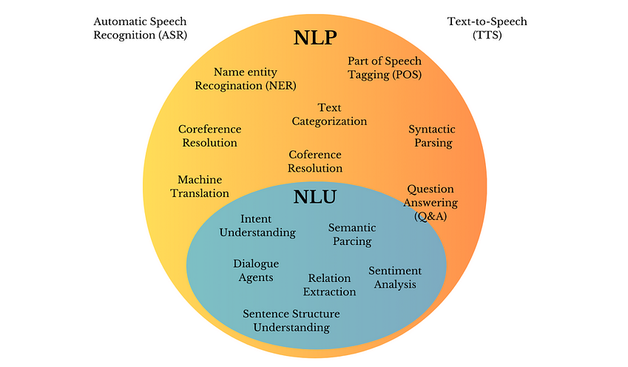

[[](https://medium.com/@vipra_singh?source=read_next_recirc-----54772c6d973a----0---------------------ace31f7f_96b7_4cdf_bee4_35804c0b12ba-------)](https://medium.com/@vipra_singh?source=read_next_recirc-----54772c6d973a----0---------------------ace31f7f_96b7_4cdf_bee4_35804c0b12ba-------)

[Vipra Singh](https://medium.com/@vipra_singh?source=read_next_recirc-----54772c6d973a----0---------------------ace31f7f_96b7_4cdf_bee4_35804c0b12ba-------)

**[LLM Architectures Explained: NLP Fundamentals (Part 1)](https://medium.com/@vipra_singh/llm-architectures-explained-nlp-fundamentals-part-1-de5bf75e553a?source=read_next_recirc-----54772c6d973a----0---------------------ace31f7f_96b7_4cdf_bee4_35804c0b12ba-------)**

[Deep Dive into the architecture & building of real-world applications leveraging NLP Models starting from RNN to the Transformers.](https://medium.com/@vipra_singh/llm-architectures-explained-nlp-fundamentals-part-1-de5bf75e553a?source=read_next_recirc-----54772c6d973a----0---------------------ace31f7f_96b7_4cdf_bee4_35804c0b12ba-------)

Aug 15

[1K](https://medium.com/@vipra_singh/llm-architectures-explained-nlp-fundamentals-part-1-de5bf75e553a?source=read_next_recirc-----54772c6d973a----0---------------------ace31f7f_96b7_4cdf_bee4_35804c0b12ba-------)

[9](https://medium.com/@vipra_singh/llm-architectures-explained-nlp-fundamentals-part-1-de5bf75e553a?source=read_next_recirc-----54772c6d973a----0---------------------ace31f7f_96b7_4cdf_bee4_35804c0b12ba-------)

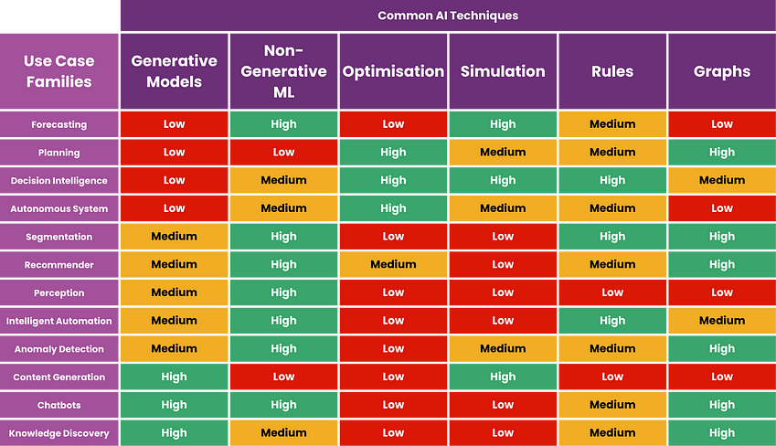

[[](https://medium.com/@christophertao?source=read_next_recirc-----54772c6d973a----1---------------------ace31f7f_96b7_4cdf_bee4_35804c0b12ba-------)](https://medium.com/@christophertao?source=read_next_recirc-----54772c6d973a----1---------------------ace31f7f_96b7_4cdf_bee4_35804c0b12ba-------)

[Christopher Tao](https://medium.com/@christophertao?source=read_next_recirc-----54772c6d973a----1---------------------ace31f7f_96b7_4cdf_bee4_35804c0b12ba-------)

in

[Towards AI](https://medium.com/towards-artificial-intelligence?source=read_next_recirc-----54772c6d973a----1---------------------ace31f7f_96b7_4cdf_bee4_35804c0b12ba-------)

**[Do Not Use LLM or Generative AI For These Use Cases](https://medium.com/towards-artificial-intelligence/do-not-use-llm-or-generative-ai-for-these-use-cases-a819ae2d9779?source=read_next_recirc-----54772c6d973a----1---------------------ace31f7f_96b7_4cdf_bee4_35804c0b12ba-------)**

[Choose correct AI techniques for the right use case families](https://medium.com/towards-artificial-intelligence/do-not-use-llm-or-generative-ai-for-these-use-cases-a819ae2d9779?source=read_next_recirc-----54772c6d973a----1---------------------ace31f7f_96b7_4cdf_bee4_35804c0b12ba-------)

Aug 10

[1.6K](https://medium.com/towards-artificial-intelligence/do-not-use-llm-or-generative-ai-for-these-use-cases-a819ae2d9779?source=read_next_recirc-----54772c6d973a----1---------------------ace31f7f_96b7_4cdf_bee4_35804c0b12ba-------)

[19](https://medium.com/towards-artificial-intelligence/do-not-use-llm-or-generative-ai-for-these-use-cases-a819ae2d9779?source=read_next_recirc-----54772c6d973a----1---------------------ace31f7f_96b7_4cdf_bee4_35804c0b12ba-------)

Lists

[[](https://tomsmith585.medium.com/list/generative-ai-recommended-reading-508b0743c247?source=read_next_recirc-----54772c6d973a--------------------------------)](https://tomsmith585.medium.com/list/generative-ai-recommended-reading-508b0743c247?source=read_next_recirc-----54772c6d973a--------------------------------)

[[](https://tomsmith585.medium.com/list/generative-ai-recommended-reading-508b0743c247?source=read_next_recirc-----54772c6d973a--------------------------------)](https://tomsmith585.medium.com/list/generative-ai-recommended-reading-508b0743c247?source=read_next_recirc-----54772c6d973a--------------------------------)

[[](https://tomsmith585.medium.com/list/generative-ai-recommended-reading-508b0743c247?source=read_next_recirc-----54772c6d973a--------------------------------)](https://tomsmith585.medium.com/list/generative-ai-recommended-reading-508b0743c247?source=read_next_recirc-----54772c6d973a--------------------------------)

[Generative AI Recommended Reading](https://tomsmith585.medium.com/list/generative-ai-recommended-reading-508b0743c247?source=read_next_recirc-----54772c6d973a--------------------------------)

[52 stories·1294 saves](https://tomsmith585.medium.com/list/generative-ai-recommended-reading-508b0743c247?source=read_next_recirc-----54772c6d973a--------------------------------)

[[](https://medium.com/@MediumForTeams/list/what-is-chatgpt-7a5756752f49?source=read_next_recirc-----54772c6d973a--------------------------------)](https://medium.com/@MediumForTeams/list/what-is-chatgpt-7a5756752f49?source=read_next_recirc-----54772c6d973a--------------------------------)

[[](https://medium.com/@MediumForTeams/list/what-is-chatgpt-7a5756752f49?source=read_next_recirc-----54772c6d973a--------------------------------)](https://medium.com/@MediumForTeams/list/what-is-chatgpt-7a5756752f49?source=read_next_recirc-----54772c6d973a--------------------------------)

[[](https://medium.com/@MediumForTeams/list/what-is-chatgpt-7a5756752f49?source=read_next_recirc-----54772c6d973a--------------------------------)](https://medium.com/@MediumForTeams/list/what-is-chatgpt-7a5756752f49?source=read_next_recirc-----54772c6d973a--------------------------------)

[What is ChatGPT?](https://medium.com/@MediumForTeams/list/what-is-chatgpt-7a5756752f49?source=read_next_recirc-----54772c6d973a--------------------------------)

[9 stories·424 saves](https://medium.com/@MediumForTeams/list/what-is-chatgpt-7a5756752f49?source=read_next_recirc-----54772c6d973a--------------------------------)

[[](https://medium.com/@MediumStaff/list/the-new-chatbots-chatgpt-bard-and-beyond-5969c7449b7f?source=read_next_recirc-----54772c6d973a--------------------------------)](https://medium.com/@MediumStaff/list/the-new-chatbots-chatgpt-bard-and-beyond-5969c7449b7f?source=read_next_recirc-----54772c6d973a--------------------------------)

[[](https://medium.com/@MediumStaff/list/the-new-chatbots-chatgpt-bard-and-beyond-5969c7449b7f?source=read_next_recirc-----54772c6d973a--------------------------------)](https://medium.com/@MediumStaff/list/the-new-chatbots-chatgpt-bard-and-beyond-5969c7449b7f?source=read_next_recirc-----54772c6d973a--------------------------------)

[[](https://medium.com/@MediumStaff/list/the-new-chatbots-chatgpt-bard-and-beyond-5969c7449b7f?source=read_next_recirc-----54772c6d973a--------------------------------)](https://medium.com/@MediumStaff/list/the-new-chatbots-chatgpt-bard-and-beyond-5969c7449b7f?source=read_next_recirc-----54772c6d973a--------------------------------)

[The New Chatbots: ChatGPT, Bard, and Beyond](https://medium.com/@MediumStaff/list/the-new-chatbots-chatgpt-bard-and-beyond-5969c7449b7f?source=read_next_recirc-----54772c6d973a--------------------------------)

[12 stories·445 saves](https://medium.com/@MediumStaff/list/the-new-chatbots-chatgpt-bard-and-beyond-5969c7449b7f?source=read_next_recirc-----54772c6d973a--------------------------------)

[[](https://medium.com/@AMGAS14/list/natural-language-processing-0a856388a93a?source=read_next_recirc-----54772c6d973a--------------------------------)](https://medium.com/@AMGAS14/list/natural-language-processing-0a856388a93a?source=read_next_recirc-----54772c6d973a--------------------------------)

[[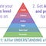](https://medium.com/@AMGAS14/list/natural-language-processing-0a856388a93a?source=read_next_recirc-----54772c6d973a--------------------------------)](https://medium.com/@AMGAS14/list/natural-language-processing-0a856388a93a?source=read_next_recirc-----54772c6d973a--------------------------------)

[[](https://medium.com/@AMGAS14/list/natural-language-processing-0a856388a93a?source=read_next_recirc-----54772c6d973a--------------------------------)](https://medium.com/@AMGAS14/list/natural-language-processing-0a856388a93a?source=read_next_recirc-----54772c6d973a--------------------------------)

[Natural Language Processing](https://medium.com/@AMGAS14/list/natural-language-processing-0a856388a93a?source=read_next_recirc-----54772c6d973a--------------------------------)

[1656 stories·1231 saves](https://medium.com/@AMGAS14/list/natural-language-processing-0a856388a93a?source=read_next_recirc-----54772c6d973a--------------------------------)

[[](https://medium.com/@valentinaalto?source=read_next_recirc-----54772c6d973a----0---------------------ace31f7f_96b7_4cdf_bee4_35804c0b12ba-------)](https://medium.com/@valentinaalto?source=read_next_recirc-----54772c6d973a----0---------------------ace31f7f_96b7_4cdf_bee4_35804c0b12ba-------)

[Valentina Alto](https://medium.com/@valentinaalto?source=read_next_recirc-----54772c6d973a----0---------------------ace31f7f_96b7_4cdf_bee4_35804c0b12ba-------)

**[Introducing Agent-based RAG](https://medium.com/@valentinaalto/introducing-agent-based-rag-9b7141ae1cd7?source=read_next_recirc-----54772c6d973a----0---------------------ace31f7f_96b7_4cdf_bee4_35804c0b12ba-------)**

[An implementation with LangGraph, Azure AI Search and Azure OpenAI GPT-4o](https://medium.com/@valentinaalto/introducing-agent-based-rag-9b7141ae1cd7?source=read_next_recirc-----54772c6d973a----0---------------------ace31f7f_96b7_4cdf_bee4_35804c0b12ba-------)

6d ago

[135](https://medium.com/@valentinaalto/introducing-agent-based-rag-9b7141ae1cd7?source=read_next_recirc-----54772c6d973a----0---------------------ace31f7f_96b7_4cdf_bee4_35804c0b12ba-------)

[2](https://medium.com/@valentinaalto/introducing-agent-based-rag-9b7141ae1cd7?source=read_next_recirc-----54772c6d973a----0---------------------ace31f7f_96b7_4cdf_bee4_35804c0b12ba-------)

[[](https://medium.com/@derekcardwell?source=read_next_recirc-----54772c6d973a----1---------------------ace31f7f_96b7_4cdf_bee4_35804c0b12ba-------)](https://medium.com/@derekcardwell?source=read_next_recirc-----54772c6d973a----1---------------------ace31f7f_96b7_4cdf_bee4_35804c0b12ba-------)

[Derek Johnson](https://medium.com/@derekcardwell?source=read_next_recirc-----54772c6d973a----1---------------------ace31f7f_96b7_4cdf_bee4_35804c0b12ba-------)

**[I’m Unemployed for Over Two Years (as a software engineer)](https://medium.com/@derekcardwell/im-unemployed-for-over-two-years-as-a-software-engineer-bd1ad6f95a54?source=read_next_recirc-----54772c6d973a----1---------------------ace31f7f_96b7_4cdf_bee4_35804c0b12ba-------)**

[In 2022, I worked on a contract as a software engineer at Apple. Apple dissolved our entire team right before the 2022 tech recession…](https://medium.com/@derekcardwell/im-unemployed-for-over-two-years-as-a-software-engineer-bd1ad6f95a54?source=read_next_recirc-----54772c6d973a----1---------------------ace31f7f_96b7_4cdf_bee4_35804c0b12ba-------)

Jun 1

[6.7K](https://medium.com/@derekcardwell/im-unemployed-for-over-two-years-as-a-software-engineer-bd1ad6f95a54?source=read_next_recirc-----54772c6d973a----1---------------------ace31f7f_96b7_4cdf_bee4_35804c0b12ba-------)

[170](https://medium.com/@derekcardwell/im-unemployed-for-over-two-years-as-a-software-engineer-bd1ad6f95a54?source=read_next_recirc-----54772c6d973a----1---------------------ace31f7f_96b7_4cdf_bee4_35804c0b12ba-------)

[[](https://medium.com/@israelsoliz?source=read_next_recirc-----54772c6d973a----2---------------------ace31f7f_96b7_4cdf_bee4_35804c0b12ba-------)](https://medium.com/@israelsoliz?source=read_next_recirc-----54772c6d973a----2---------------------ace31f7f_96b7_4cdf_bee4_35804c0b12ba-------)

[Israel Soliz](https://medium.com/@israelsoliz?source=read_next_recirc-----54772c6d973a----2---------------------ace31f7f_96b7_4cdf_bee4_35804c0b12ba-------)

**[What is AI, Really? A Simple Explanation for Non-Techies](https://medium.com/@israelsoliz/what-is-ai-really-a-simple-explanation-for-non-techies-fffabf492b39?source=read_next_recirc-----54772c6d973a----2---------------------ace31f7f_96b7_4cdf_bee4_35804c0b12ba-------)**

[Alright, let’s cut through the hype and jargon. What the heck is AI, and why should you, a busy professional, even care?](https://medium.com/@israelsoliz/what-is-ai-really-a-simple-explanation-for-non-techies-fffabf492b39?source=read_next_recirc-----54772c6d973a----2---------------------ace31f7f_96b7_4cdf_bee4_35804c0b12ba-------)

May 28

[1](https://medium.com/@israelsoliz/what-is-ai-really-a-simple-explanation-for-non-techies-fffabf492b39?source=read_next_recirc-----54772c6d973a----2---------------------ace31f7f_96b7_4cdf_bee4_35804c0b12ba-------)

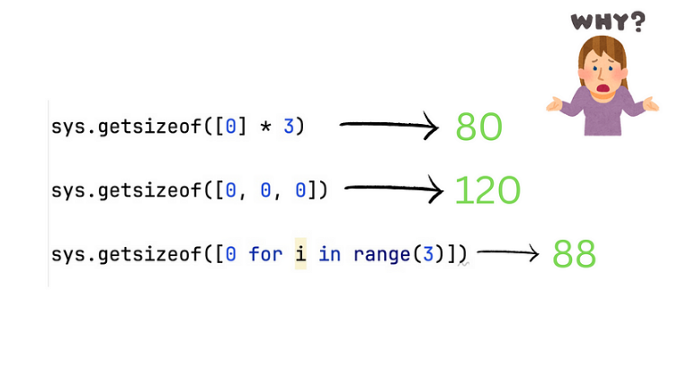

https://medium.com/nerd-for-tech/ai-search-algorithms-with-examples-54772c6d973a#id_token=eyJhbGciOiJSUzI1NiIsImtpZCI6ImE0OTM5MWJmNTJiNThjMWQ1NjAyNTVjMmYyYTA0ZTU5ZTIyYTdiNjUiLCJ0eXAiOiJKV1QifQ..QWR0s_YTxrn-VzYLO5_t1GYQEPKEBPAiLZVMSTnmSIq_zuDPjcFAXPxq904vTQBCbmRYkjMAoHW0mAXhFMZqy8JxGabBDxUMv_2Tycfs2NZpGq89B6MkX9epsuFmsMCYNHWECDuAzszFyKMb7kt_Ss6f4QGbgwktk__vosWdCj8XyhuB8P3HSdVzUWmGyUl-vZS4uSKBt0r6LNsyDiyOn6QF-Vb17msi-JAYDPiScRzb7TI3LkzdZM5wb3fkdRfdcbyqho2IpwDITvIgXv4RdYOV8HGUxs25UyVv_jKzqALaaXba29knZfhVik3oScvFoycQR1BcbG-o2sWL77szIQ

<https://www.engati.com/glossary/admissible-heuristic>

**Admissible heuristic**

**Table of contents**

* [What are Admissible heuristics?](https://www.engati.com/glossary/admissible-heuristic#toc-what-are-admissible-heuristics-)
* [What is non-admissible heuristic?](https://www.engati.com/glossary/admissible-heuristic#toc-what-is-non-admissible-heuristic-)
* [What happens when a heuristic is not admissible?](https://www.engati.com/glossary/admissible-heuristic#toc-what-happens-when-a-heuristic-is-not-admissible-)
* [What is the difference between admissible heuristics & consistent heuristics?](https://www.engati.com/glossary/admissible-heuristic#toc-what-is-the-difference-between-admissible-heuristics-consistent-heuristics-)
* [How does an admissible heuristic ensure an optimal solution?](https://www.engati.com/glossary/admissible-heuristic#toc-how-does-an-admissible-heuristic-ensure-an-optimal-solution-)

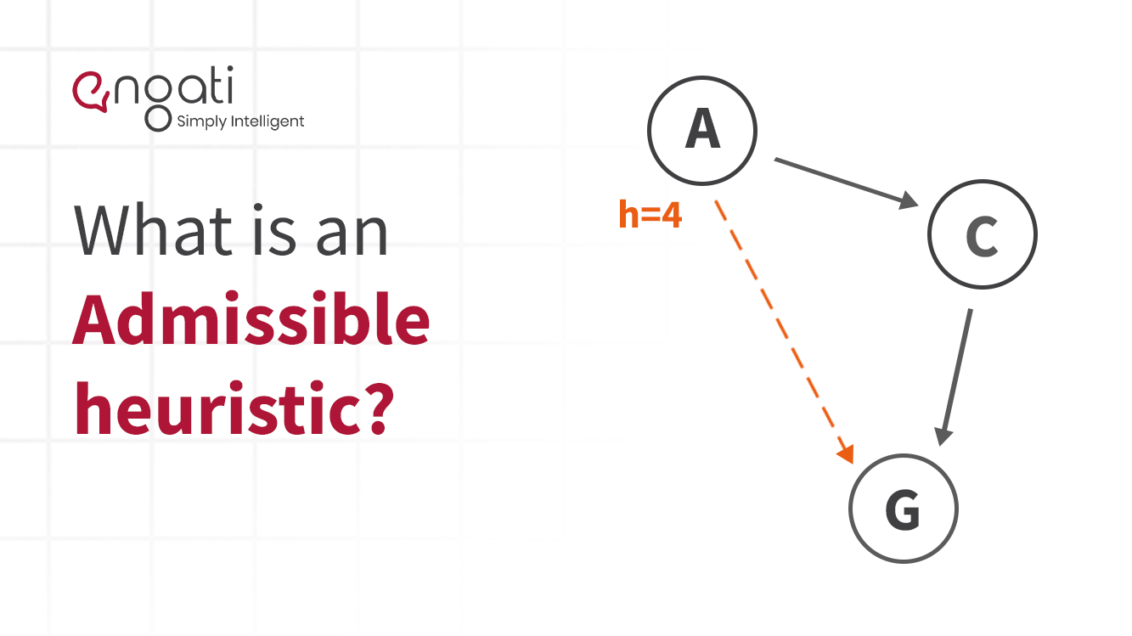

**What are Admissible heuristics?**

Admissible heuristics are used to estimate the cost of reaching the goal state in a search algorithm. Admissible heuristics never overestimate the cost of reaching the goal state. The use of admissible heuristics also results in optimal solutions as they always find the cheapest path solution.

For a heuristic to be admissible to a search problem, needs to be lower than or equal to the actual cost of reaching the goal.

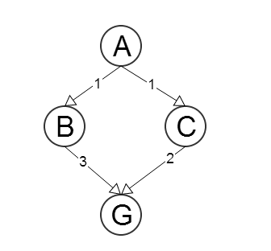

Source: [Computer Science Stack Exchange](https://cs.stackexchange.com/questions/16065/how-does-an-admissible-heuristic-ensure-an-optimal-solution)

‍

Here is an example:

In the A* search algorithm, the evaluation function (where {\displaystyle n}n is the current node) is:

f(n)=g(n)+h(n)

where

f(n) = evaluation function.

g(n) = cost from start node to current node

h(n) = estimated cost from current node to goal

Here, h(n) gets calculated with the use of the heuristic function. If a non-admissible heuristic was used, it is possible that the algorithm would not reach the optimal solution because of an overestimation in the evaluation function.

‍**What is non-admissible heuristic?**

Non-admissible heuristics may overestimate the cost of reaching the goal state. There is no guarantee that they will reach an optimal solution.

**What happens when a heuristic is not admissible?**

When a non-admissible heuristic is used in an [algorithm](https://www.engati.com/glossary/algorithms), it may or may not result in an optimal solution.

But, sometimes non-admissible heuristics expand a smaller amount of nodes. As a result, it is possible that the total cost (search cost + path cost) could end up being lower than an optimal solution that would be found by using an [admissible heuristic](https://en.wikipedia.org/wiki/Admissible_heuristic).

‍

**What is the difference between admissible heuristics & consistent heuristics?**

A heuristic is considered to be consistent if the estimated cost from one node to the successor node, added to the estimated cost from the successor node to the goal is less than or equal to the estimated cost from the current node to the goal state.

In an admissible heuristic, the estimated cost from the current node to the goal state is never greater than the actual cost.

All consistent heuristics are admissible heuristics, however, all admissible heuristics are not necessarily consistent heuristics.

**How does an admissible heuristic ensure an optimal solution?**

If the heuristic function isn’t admissible, then it is possible to have an estimation that is larger than the actual path cost from some node to a goal node. If this higher path cost estimation is on the least cost path (that you are trying to find), the algorithm will not explore it and it may find another (not the cheapest) path to the goal.

Consider this example:

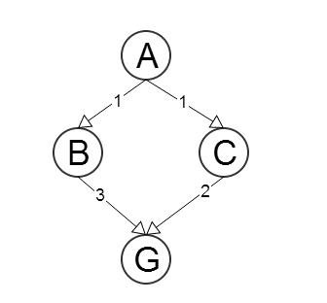

Say 𝐴  and 𝐺 are the starting and goal nodes respectively. Now let ℎ(𝑁) be an estimate of the path's length from node 𝑁 to 𝐺, ∀𝑁 in the graph. Say 𝑐(𝑁,𝑋𝑖) is the step cost function from node 𝑁 to its neighbor 𝑋𝑖, ∀𝑁 and 𝑖=1..𝑚, where 𝑚 is the number of neighbors of 𝑁 (i.e., a function that returns the cost of the edge between node 𝑁 and one of its neighbors).

Let the heuristics be

* ℎ(𝐵)=3
* ℎ(𝐶)=4

This heuristics function 𝐻 will not be admissible, because

ℎ(𝐶)=4>𝑐(𝐶,𝐺)=2

If the 𝐴∗ algorithm starts from node 𝐴, it will then select the node 𝐵 for the purpose of expansion and, after this, it will proceed to node 𝐺 from there. And the path will be 𝐴→𝐵→𝐺 with cost 4, instead of 𝐴→𝐶→𝐺 with cost 3. If the heuristic function was admissible this would not have happened.

if the heuristic had been admissible A->B could be chosen for the next node to expand, but after that, the A* would select A->C instead of A->B->G. And in the end, it would end up with A->C->G.

This is because of the way in which  A* works. It expands the node that has the least sum of the distance to that node + heuristic estimation from that node. d(A,G) + h(G) = 4 + 0 = 4 and d(A,C) + h(C) = 1 + something<=2 (because it is admissible). C has the lower sum and hence A* will pick it. In the same way, it will then expand G and identify the least path.

Admissible heuristics make sure to find the shortest path with the least cost. The solution itself will be optimal if the heuristic is consistent.

Here is an alternative explanation:

The fact that the heuristic is admissible means that it does not overestimate the effort to reach the goal. i.e., ℎ(𝑛)≤ℎ∗(𝑛) for all 𝑛 in the state space (in the 8-puzzle, which means is that just for any permutation of the tiles and the goal you are currently considering) where ℎ∗(𝑛) is the optimal cost to reach the target.

The most logical reason why 𝐴∗ offers optimal solutions if ℎ(𝑛) is admissible is due to the fact that it sorts all nodes in OPEN in ascending order of 𝑓(𝑛)=𝑔(𝑛)+ℎ(𝑛) and, also, because it does not stop when generating the goal but when expanding it.

Due to the fact that nodes are expanded in ascending order of 𝑓(𝑛) you know that no other node is more promising than the current one. ℎ(𝑛)  is admissible so that having the lowest 𝑓(𝑛) means that it has an opportunity to reach the goal via a cheaper path that the other nodes in OPEN have not. This holds true unless you can manage to prove the opposite, i.e., by expanding the current node.

Because 𝐴∗ will only stop when it proceeds to expand the goal node (instead of stopping when generating it) you can be absolutely sure that no other node leads to it via a cheaper path.

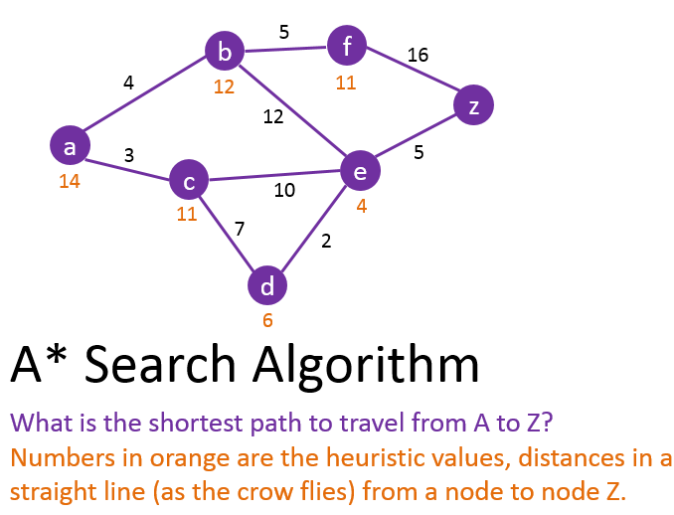

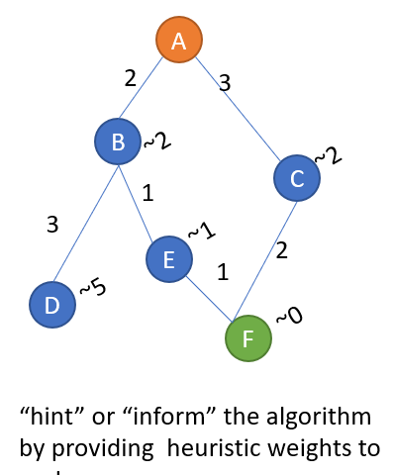

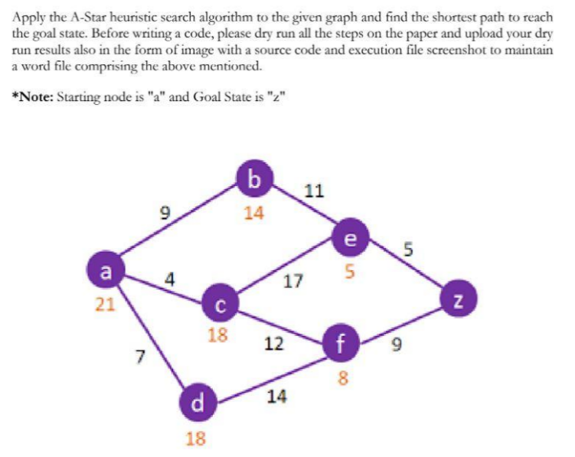

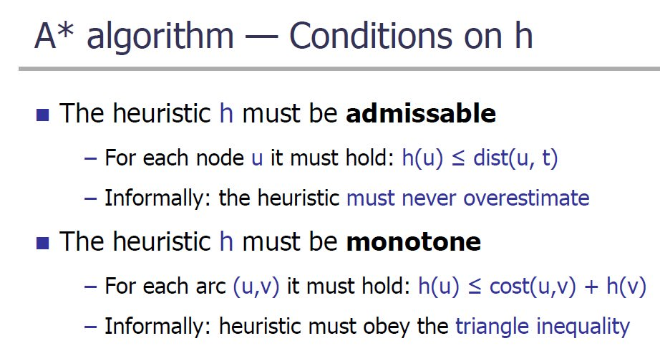

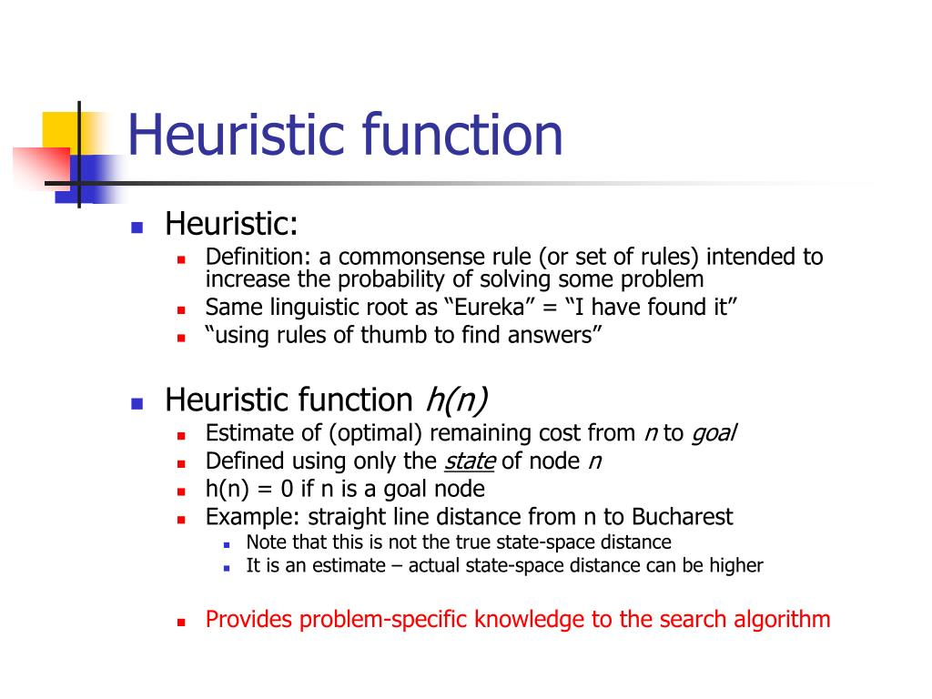

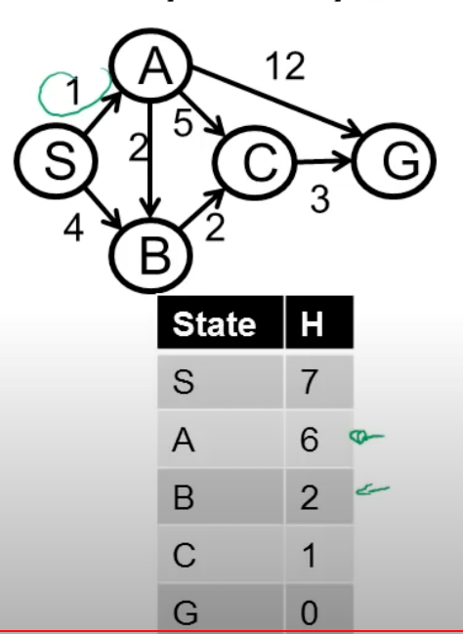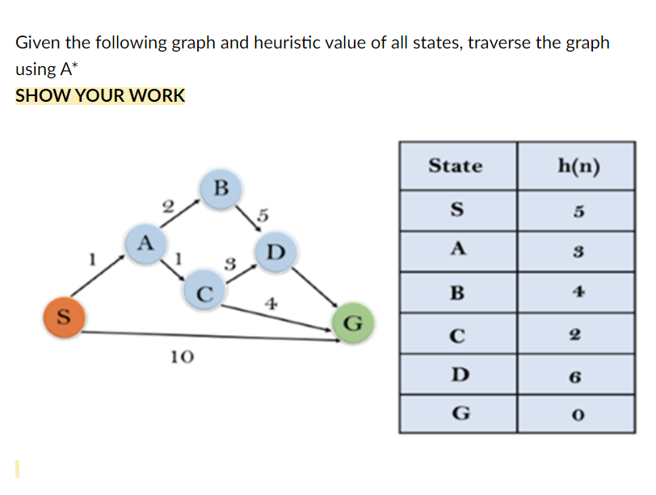

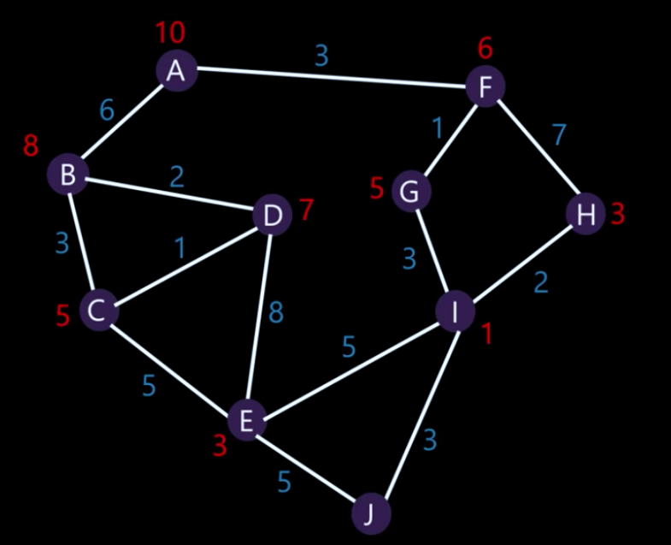

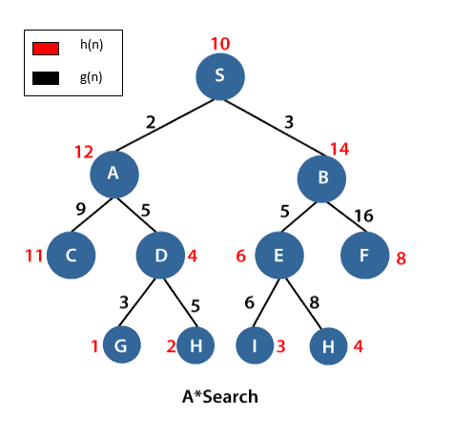

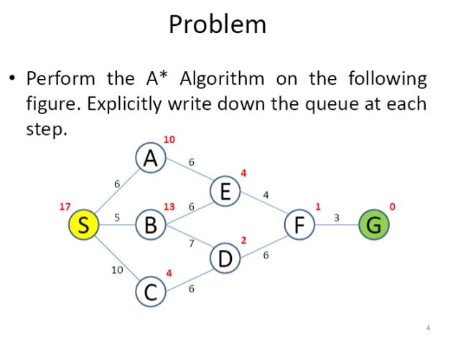

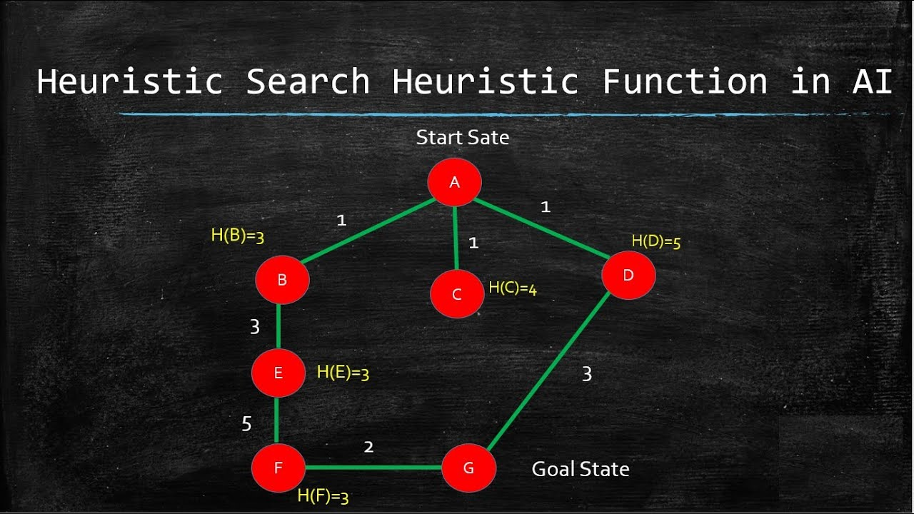

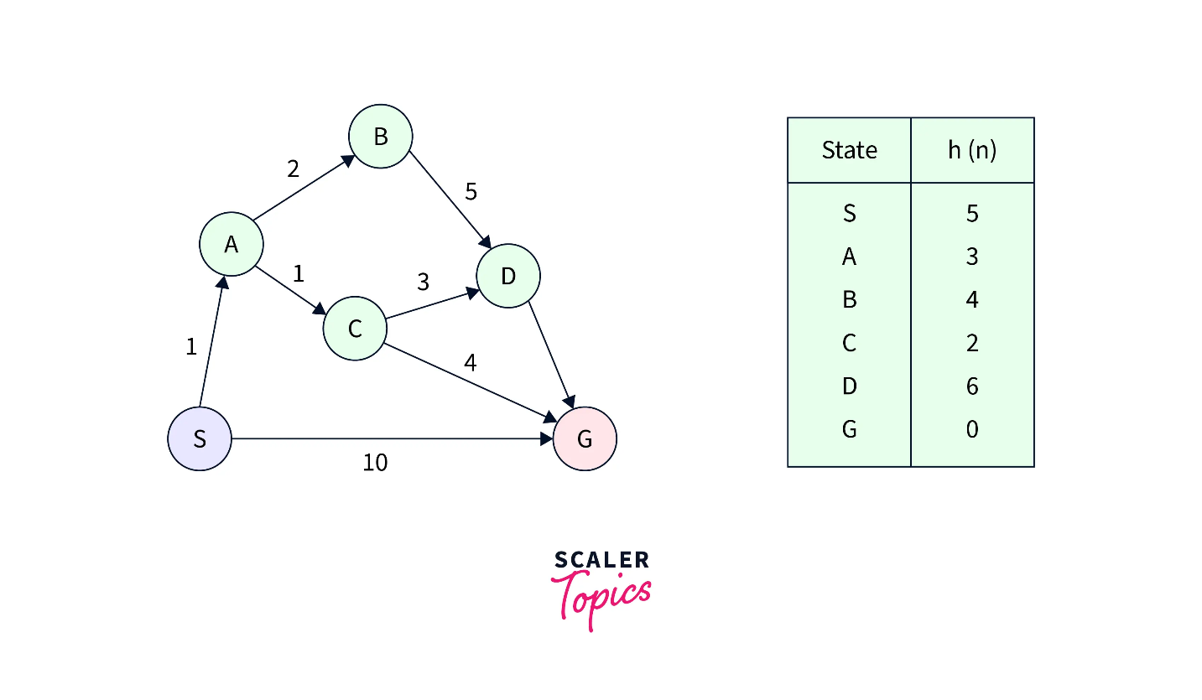

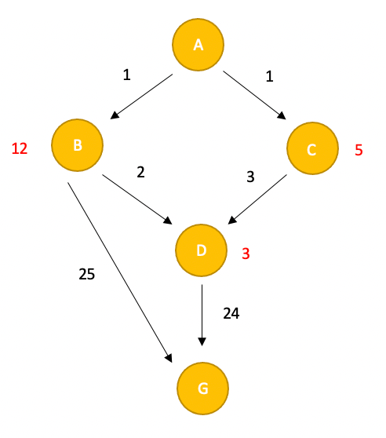

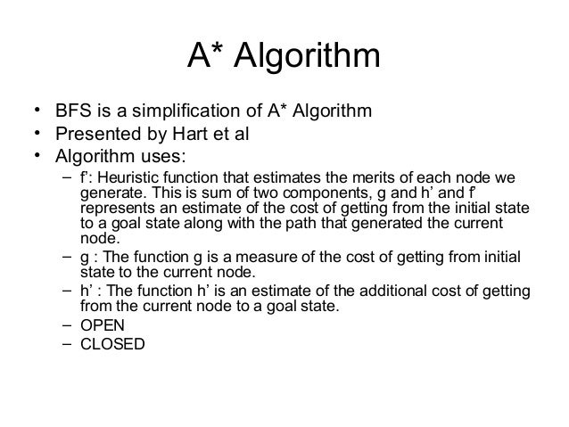

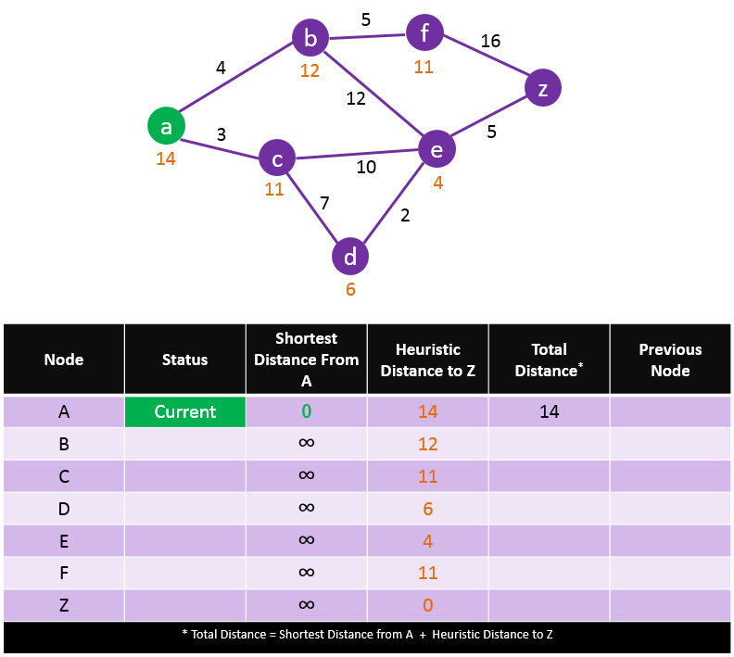

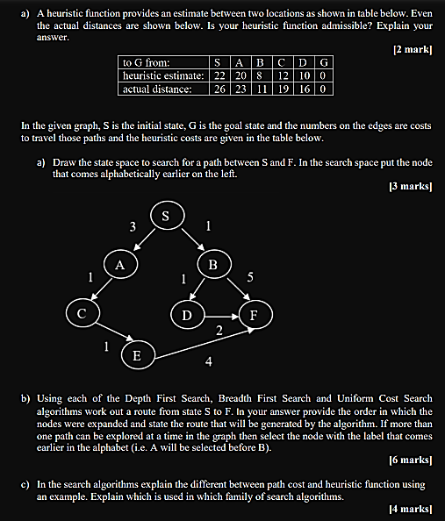

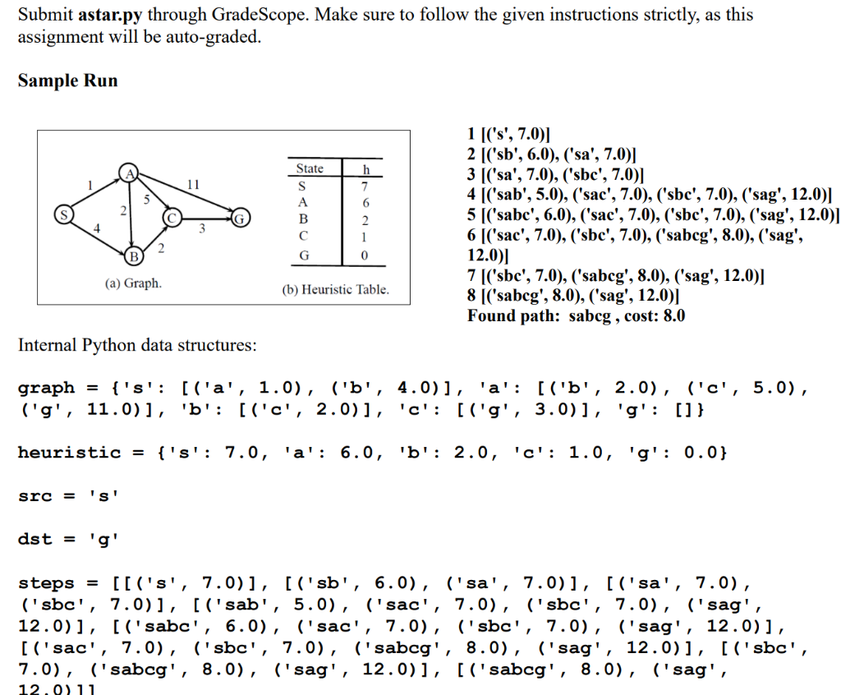

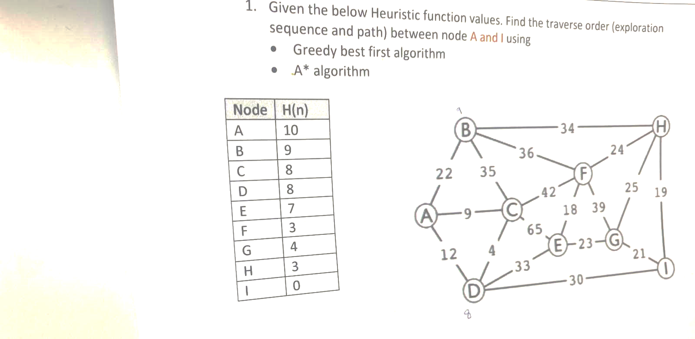

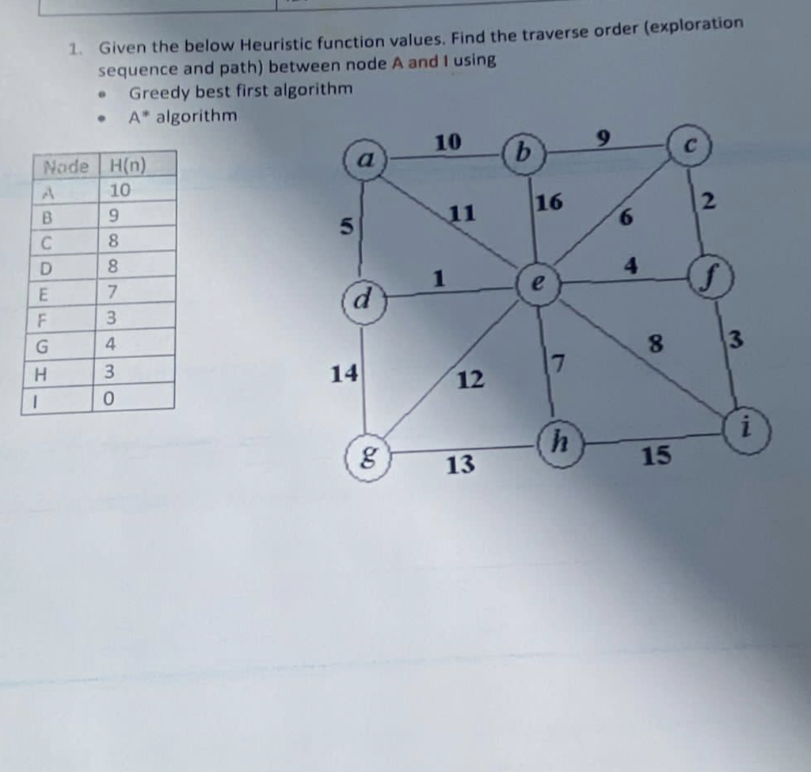

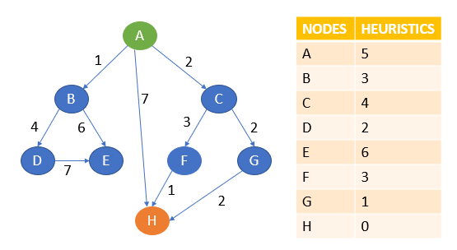

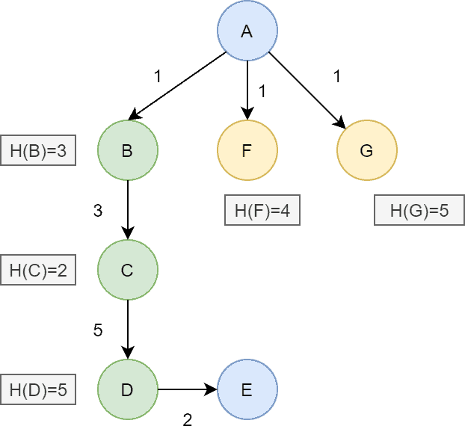

**Given the graph and Heuristic, show the steps of Dijkstra algorithm and A star algorithm (From S node to G node).**

